**Improving Power Grid Visualizations for Optimal Data Comparisons**

Emma Cohen, Michael Clark, Paige Miller

ecohen2, mtc3, pmmille

**Background and Motivation:**

One of our group members has a background in electrical engineering, specifically power analysis. This means they spend a lot of time looking at different drawings of power grids, substation wirings and basic circuits. One of the papers the group found while doing research involved a novel way of designing power grid drawings for visualization. Current technical drawings show great detail for allowing engineers to wire circuits correctly but the visualization techniques recommended in this paper will allow for proper data comparisons and highlight trends or anomilies in power grid design or real world application. The idea for this project comes from a journal article published in “IEEE Transactions on Visualization and Computer Graphics” published in 2009 titled “A Novel Visualization Technique for Electric Power Grid Analytics” (1).

**Project Objectives:**

The main questions to be answered in this visualization proposal are: “How much power is lost between buses? How does line length relate to power loss? Which busses see more power flow?” The benefits of this visualization tactic break into two major categories: engineering and data analysis. On the engineering side, the visualization is helpful for planning and monitoring. Using this approach, engineers are able to see what parts of the grid are doing well, where improvements can be made and where maintenance requests may need to focus. This will also help identify the vulnerabilities of the power grid and evaluate its strengths and weaknesses. Another benefit is that as the popularity of microgrids grows, the grid visualizations can become more detailed and process heavy, allowing more data to be included in line diagrams. This leads into the data analytics benefit, which is that more detail can be shared to be studied. This includes geographical layout, color schema, line depth and more that usually cannot be included due to the scale of typical grid diagrams and the computer processing power and time needed to run any simulation of that scale. By limiting the size of grids analyzed, the freedom to include more data and use more data visualization techniques is available.

**Data:**

The data acquired for this project is coming from Clemson University main campus, collected in the summer of 2020. The link for the data is given here: <https://drive.google.com/drive/folders/1-FVwSLFUoO4FGESbw_2BWXN3PuY7mUbf?usp=sharing>

This folder contains data in excess and not all of it will be used. The folder will be updated throughout the course of the project to reflect accuracy as progress is made. This data was acquired directly from Schneider Electric, the company that installed and maintains Clemson’s power generation and distribution.

**Data Processing:**

The data in the folder above is extremely extensive and as mentioned, most likely will not all be used. Most of the excel documents list data collected at different places at 15 minute intervals over the course of a few months. There certainly will be substantial data clean up and only some segments/time points will be used as fit. The most important quantities that will be collected from the data sets are time points, power read, bus values and line lengths.

**Visualization Design:**

The data will be visualized through network trees or some alternate form that closely resembles a node/network tree. The depths of the lines will equate the length of the power lines (i.e.the thicker the line, the longer the power line). Additionally, the size of the nodes will indicate the power usage of the nodes (i.e. the larger the node, the more power that node uses). Furthermore, we will consider using colors to indicate power loss at the nodes. For example, one color would represent more power loss and another would represent less power loss on a color gradient. Lastly, there will be a geographical component to the diagrams. Rather than the nodes and arcs being displayed randomly throughout the visualization there will be some order so that they are displayed similarly to how they are network throughout the physical grid.

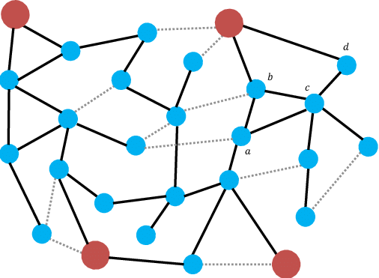

1) This is a basic tree design of a power grid with the substations colored red, planned/open lines are dotted, real lines are solid and buses are blue (2).

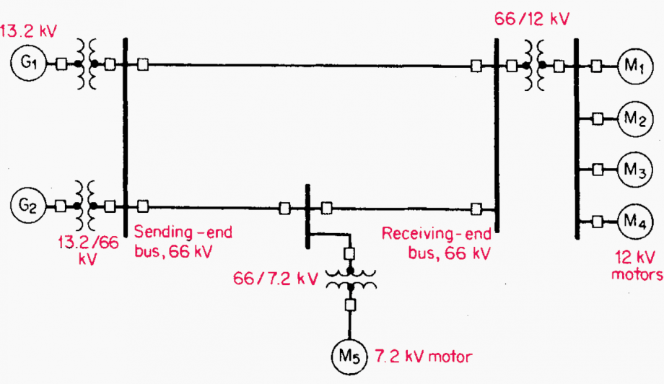

2) This is a detailed diagram of a one-line drawing. The G stands for generators, the squiggly lines are power transformers, showing a step up or down in power, the vertical lines are buses and the horizontal lines show connections between busses (3).

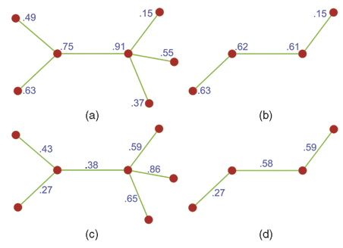

3) This is a basic diagram to show how coarser lines could be implemented in the research paper. The numbers denote power given in per unit (1).

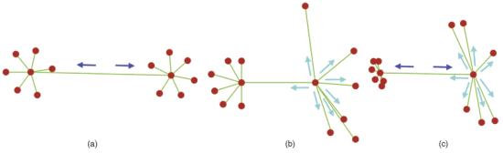

4) The links connecting the notes are weighted heavier between clusters in (a), the node weight is changed in (b) and both are shown in (c) (1).

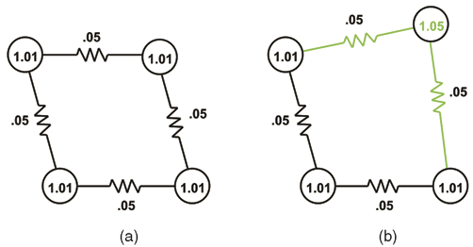

5) This diagram shows line impedances and in (b) shows distortion to emphasize the difference in value in the top right node (1).

**Must-Have Features:**

A must-have feature would be identification of the grid. Meaning some type of label/short explanation that lets the viewers know what they are looking at, especially the location of the grid. Another must-have feature would be some form of an identifier at each node so that you know how much power each node is using. This identifier could be in the form of a number, color, size of node, etc. This is an important feature because it is one of the features that makes the visualization most readable to the person visualizing.

**Optional Features:**

An optional feature would be one where the nodes are labeled so that a person knows what exactly the node represents; however, it's not critical to the visualization of the power grid.

**Project Schedule:**

The week of 17 October we will continue working on the visualizations ensuring that we have thorough and creative ways to visualize the grid in methods that align with our chosen research paper.

The week of 24 October the group will meet to finalize the design of the website. This will happen after the instructor has given feedback on the shell of the website that was submitted for the project proposal. Though all of the content will not be in place we will know what the final website will look like.

The week of 31 October will be completing the project prototype assignment and working early to ensure that our prototype is to our standard and appropriately presentable for the turn-in due the next week.

The week of 7 November, the team will turn in the project prototype and wait on feedback from the instructor. We will individually work on the peer evaluations which are due the following week ensuring that we give fair and honest feedback for each of the groups which will in turn help everyone in the course to perform better when they are provided with constructive criticism.

The week of 14 and 21 November the team will extensively review the peer evaluations and prepare for the final delivery and oral presentation. The focus will be on the oral presentation the week of the 21st.

The week of 28 November we will finalize the delivery and get feedback from the instructor before we turn in the final product. Additionally, we will individually work on the peer assessments for each of the group members.

**Resources:**

1. P. C. Wong et al., "A Novel Visualization Technique for Electric Power Grid Analytics," in IEEE Transactions on Visualization and Computer Graphics, vol. 15, no. 3, pp. 410-423, May-June 2009, doi: 10.1109/TVCG.2008.197. https://ieeexplore.ieee.org/document/4695829
2. <https://www.researchgate.net/figure/Example-of-a-power-grid-with-4-substations-Substations-are-represented-by-large-red_fig1_318271802>
3. <https://electrical-engineering-portal.com/calculate-draw-single-line-diagram-power-system>